# A general catch comparison method for multi-gear trials: application to a quad-rig trawling fishery for *Nephrops*

Browne, D1*., Minto, C. 2, Cosgrove, R. 1, Burke, B. 2, McDonald, D. 1, Officer, R. 2, and Keatinge, M1.

1 Irish Sea Fisheries Board (BIM), New Docks, Galway, Ireland.

2 Marine and Freshwater Research Centre, Galway Mayo Institute of Technology (GMIT), Dublin Road, Galway, Ireland.

*Corresponding author: tel: +353 91539360; fax: +353 91568569; e-mail: [browned@bim.ie](mailto:browned@bim.ie)

## Abstract

Expeditious uptake of quad-rig trawling in the economically important Irish fishery for *Nephrops Norvegicus* outpaced technical understanding of catch performance in this new gear. The main driver for increased use of this gear is increased catch rates of *Nephrops*. However, discarding of demersal species is likely to have negative impacts on the economics of quad-rig trawling for *Nephrops* unless species and size-selectivity can be improved. Catch comparison methods are suitable for assessing the performance of fishing gear modifications to reduce fisheries bycatch. Utilising a quad-rig potentially increases the number of gears that can be included in a catch comparison study to four but current modelling methods which include error measurements are limited to two gears. Our study provides a statistical framework that can be applied when two or more gears are used, elucidates how case-specific and choice-specific covariates may influence catches, and facilitates discussion on appropriate gear based management measures. We provide a new general multinomial modelling framework that includes multivariate normal random effects to account for clustering of observations at the haul level. Application of the method to catches from four quad-rig cod-ends with different mesh sizes revealed significant effects of net position, catch weight per cod-end and carapace length on the numbers of *Nephrops* retained in each cod-end. Results suggest that management measures which specifically address different catch profiles associated with different numbers of trawling rigs are required to optimise bycatch reduction in *Nephrops* fisheries.

**Keywords:** Landing obligation, *Nephrops norvegicus*, multi-rig, cod-end mesh size, catch comparison, multinomial mixed effects, mixed logit.

## Introduction

*Nephrops norvegicus* is a commercially important species distributed throughout the North East Atlantic and Mediterranean Sea. Total landings of 66,500 tonnes in 2010 were predominantly attributed to the United Kingdom (58.1%) followed by Ireland (11.7%) and various other European Union (EU) countries operating in Atlantic and Mediterranean waters (FAO, 2010). More than 95% of EU *Nephrops* landings are taken using single or multi-rig trawlers which target *Nephrops* in mixed species fisheries (Ungfors et al., 2013). The high value of Irish *Nephrops* landings at the first point of sale (estimated at €44.5M in 2014) make it the most commercially important demersal species in Ireland (Cosgrove et al., 2015a). The simultaneous use of four trawls, known as quad-rig trawling (Figure 1), is practiced in shrimp trawl fisheries in the United States of America and Australia (e.g. Eayrs, 2012; Broadhurst et al., 2013) and commenced in the Irish *Nephrops* fishery in October 2012. By the end of 2014 quad-rigs accounted for ~ 80% of *Nephrops* landings by the Irish fleet (unpublished data, Marine Institute, Ireland).

The main driver for increased uptake of the quad-rig trawling is increased catch rates of *Nephrops* which are likely to result from a wider swept area of seabed without increasing the drag of the gear compared with more traditional single or twin-rig trawling, (Montgomerie, 2015). *Nephrops* catch weights were observed to increase by at least 50% in the North Sea and Celtic Sea in studies comparing quad with twin-rig trawling (Revill et al., 2009; BIM, 2014). Such increases in catch efficiency may be beneficial in terms of improving operational performance but could lead to increases in the 15% discard rate of *Nephrops* below minimum landing or market size in Irish waters (MI, 2014). Bycatch of undersized and non-targeted fish species is also a major issue in *Nephrops* trawl fisheries (e.g. Catchpole et al., 2005; Catchpole and Revill, 2008; Ungfors et al., 2013; Nikolic et al., 2015). New requirements to restrict discarding of demersal species under Article 15 of EU regulation 1380/2013, the landing obligation, are likely to have negative impacts on the economics of *Nephrops* fisheries unless species and size-selectivity can be improved.

Gear modifications to reduce bycatch are generally assessed using either selectivity (e.g. Millar, 1992; Millar and Walsh, 1992; Millar and Fryer, 1999; McClanahan and Mangi, 2004) or catch comparison studies (e.g. Sangster and Breen, 1998; Holst and Revill, 2009; Krag et al., 2014; van Marlen et al., 2014). Practical advantages of the catch comparison method include commercial-like performance and handling of the gear. In addition, the ease with which results of catch comparison experiments can be reported and interpreted (Holst and Revill, 2009) is likely to be of particular assistance to the fishing industry in addressing challenges posed by regulation of their catch composition, for example the EU landing obligation. Whilst catch comparisons can only compare the gears included in particular experiments (Frandsen, 2010), utilising a quad-rig increases the number of gears that can be evaluated in the experiment to four. This potentially allows assessment of more concurrent experimental settings and provides substantially more information than twin or single-rig catch comparisons. Development of a Generalized Linear Mixed Model (GLMM) approach to catch comparison provided a statistical and graphical comparison of fish catch at length by two fishing gears with associated error measurements, improving the power of catch comparison analyses (Holst and Revill, 2009). Binomial GLMMs are, however, limited to experiments with two response categories. Multinomial models can generalise logistic regression to multi-category response problems (McCullagh and Nelder, 1989), i.e. those with two or more fishing gears.

Here, we develop and test the potential benefits of applying a multinomial modelling approach to a comparison of *Nephrops* catches in a trawl fishery with four simultaneously deployed test gears. Our goals are to provide a general statistical framework that incorporates the multivariate response, elucidates how covariates may influence catches, and facilitates discussion on appropriate gear based management measures.

## **Materials and Methods**

Addressing the particular requirements of catch comparison in quad-rig trials required a modified trial design and modelling framework.

### Trial design

Data were collected from a catch comparison experiment conducted in the western Irish Sea, ICES sub-area VIIa, between 18/7/2015 and 21/7/2015. The trial vessel carried out multi-rig trawling using a triple warp and centre clump arrangement with 4 identical nets each fitted with a diamond mesh cod-end with nominal mesh sizes of 70, 80, 90 or 100 mm (mesh size descriptors used henceforth) (Table 1). Cod-ends were constructed with single braided 5.5 mm polyethylene twine (Eurored Abrasion). Cod-end mesh size was measured with the Omega gauge (Fonteyne et al (2005)) and the mean values (with standard error in brackets) were: 70.8 (0.3), 80.8 (0.3), 92.6 (0.2) and 103.0 (0.3) mm. Mesh size in the top and bottom panels behind the head-line and in the lower wing ends of the net was 80 mm, while mesh size in the upper wing ends was 160 mm. Corresponding to normal fishing practices in the area, square mesh panels of 120 mm mesh size were mounted 9 to 12 m from the cod-line. Here, ‘net’ describes the whole trawl body. Net positions in relation to the vessel were fixed while cod-end positions were rotated daily to account for potential differences in fishing power without confounding cod-end mesh and net position effects (Figure 1). Described as ‘net configuration’, each cod-end was deployed on each net for 3 hauls which equates to one out of four fishing days, with the data from 12 consecutive hauls analysed. Further information on the vessel and gear used in the trial is presented in Table 1. Operations approximating normal commercial fishing practice were carried out with haul duration, towing speed and depth of ground fished averaging: 04:47 h, 3.1 knots and 48 m respectively. Catches of fish and *Nephrops* were weighed and random representative subsamples were selected. *Nephrops* carapace length was recorded to the nearest mm below using digital callipers connected to a wireless recording system (Cosgrove et al., 2015a).

### Model development

In the quad-rig trial the response was a vector of *Nephrops* counts for a given haul (), length-class () and cod-end (). For example, for the 30mm length bin in haul 5, the response might be denoting that 10 *Nephrops* were counted in the first cod-end, 20 in the second, etc.

The response data are multivariate counts for which interest lies in describing how the relative proportions retained per length-class in each of the cod-ends varies as a function of the cod-end design (predominantly mesh size) and other explanatory variables. When trials result in counts per category (cod-end), a starting distribution is the multinomial (Agresti, 2002) with probability mass function

(1)

where: is the count in the th cod-end and ; and is the probability of outcome ,

, implying 3 parameters in an intercept-only model.

#### Covariates

A common model when explanatory variables are included (such as carapace length) is the multinomial logit model, where the probability of a given outcome depends on values of the explanatory variables for the th observation (row):

, (2)

where is a () row vector of explanatory variables for the th observation and is a () column vector of parameters for the th category. Note that so that the first cod-end is set to the baseline (Greene, 2000). The explanatory variables included were: carapace length, net position (the cod-end positions were changed each night to account for position effects, as detailed in the “Trial design” section above) and catch weight per cod-end. All continuous covariates were scaled to have mean zero and standard deviation of one prior to fitting, which we found improves hessian matrix estimation.

The catch weight per cod-end deserves special attention as it may require different treatment to variables such as carapace length. For a given length class and haul the carapace length is common across the four cod-ends, whereas the catch weight varies across the cod-ends: . Such “choice-specific” variables in a multinomial setting are typically modelled using conditional logit models (McFadden, 1973), which remove the subscript *k* from the parameter for that covariate. Thus in a strict conditional logit model the weight effect is . Cod-end weight influences the opening angle of the meshes and it is doubtful that the effect of weight should be common across cod-ends (e.g., a 70mm mesh might stretch less/more for a given cod-end weight than a 100mm mesh), we therefore allowed the effect of weight to differ by cod-end: . We thus use a mixture of case-specific and choice-specific covariates leading to the fixed effects model

, (3)

#### Subsampling offset

As the counts are sub-sampled, it is also necessary to include an offset for the proportion of the catch in each cod-end sampled. In a twin-rig (two category) trial the offset is given by where and are the proportions of the catch sampled in the test and control, respectively (Holst and Revill, 2009). In the quad-rig trial with the proportion of the th cod-end in the th haul sampled, the vector of offsets is given by , where the first zero comes from .

The offset is incorporated as:

, (4)

*Multinomial random effects*

Counts for category in a multinomial have an expected mean and variance , however, there is often more variability in the counts than the mean-variance (and covariance) allows for, which is termed overdispersion (Hinde and Demétrio, 1998). This may reflect uncaptured variability or clustering, in particular haul-level variability not accounted for when the observations are treated as independent multinomials. Overdispersion was indicated in the best fitting multinomial model by testing the residual deviance (-2(log-likelihood best model – log-likelihood of the saturated model)) on a chi-squared distribution with the residual degrees of freedom.

Given that the observations are clustered by hauls, the approach we focus on for accounting for extra-multinomial variability is to include random effects in the model. Multinomial random effects include the baseline category logit random effects model (Hartzel et al., 2001). This model has a multinomial response distribution with the addition of random effects that more explicitly capture the variability attributable to hauls, as opposed to the more general additional variability unattributed to specific grouping but included in, for example, the Dirichlet-multinomial model (Mosimann, 1962). The random effects multinomial model we test is an extension of Equation (4) given by

, (5)

where the random effects per haul have a multivariate normal distribution . The baseline category random effect is again set to zero, resulting in a trivariate normal distribution for . An arbitrary (6 parameter) covariance matrix structure, as recommended in Hartzel et al. (2001) was implemented.

The model contained conditional logit, multinomial logit and random effects, which does not facilitate model naming. For simplicity, we refer to the model as a “multinomial mixed effects model”.

#### Inference

We use likelihood ratio tests of nested models to test the significance of each of the fixed effects. As the models are estimated via maximum likelihood we also report Akaike’s Information Criterion for each model. Overall predictions in the presence of a categorical variable (net configuration) were obtained by setting the net configuration values in the predicted model matrix to 1/3 (Fox and John, 2003); total catch weight per cod-end in the overall predictions was set to the mean.

#### Estimation

Estimation of the multinomial random effects model necessitates integrating over the random effects to estimate the marginal likelihood. We did not find readily available software to fit Equation (7) we therefore wrote an estimation routine in Template Model Builder (TMB) (Kristensen et al., 2015) TMB implements Laplace approximations to the marginal likelihood and allows for estimates of uncertainty on the linear predictor scale. All pre- and post-processing code was run in R 3.2.0 (R_Core_Team, 2015). Code for running the multinomial mixed effects model is stored at: https://github.com/mintoc/epif/tree/master/multinomial.

## Results

A total of 15,443 *Nephrops* were measured during the 12 hauls of the trial. Most of the carapace length measurements were in the range of 20-45mm (Figure 2). Considerable between-haul variability was observed in the proportions retained at length with some hauls displaying consistently lower or higher retention across carapace lengths (Figure 2). The observed proportions at the extremes of the length distribution were more variable as they were derived from fewer observations (e.g., zero or unity proportions in Figure 2). Total *Nephrops* catch weights were 2093, 1837, 1642, and 1662 kg in the 70, 80, 90, and 100 mm cod-ends respectively. *Nephrops* accounted for approximately half the total catch weight across all hauls with the remainder of the catch primarily consisting of flatfish and gadoid species (Cosgrove et al., 2015b). An estimated deviance of 1398.84 on 994 residual degrees of freedom (338 rows of data x (4-1) cod-ends - 20 parameters) indicated significant overdispersion relative to the baseline multinomial assumption. Our results therefore focus on the multinomial mixed effect models. Separate inclusion of each of the main effects (carapace length, net positions and catch weight per cod-end) resulted in large decreases in the AIC relative to a model with fixed proportions (Table 2, models 2-4). Including an interaction between net position and mesh did not result in an improvement of the model fit (Table 2, comparison of models 3 and 10). , models 9 and 17The best fitting main effects model included carapace length, net position and catch weight (Table 2, model 16). Of the two-way interactions trialled, the model including weight x carapace length and position x carapace length had the best fit (Table 2, model 20). A fit that included the interaction between catch weight per cod-end and net position did not converge, reflecting the large number of parameters required for that interaction. Additional higher-order interactions of the explanatory variables were not included in the models, as with 12 hauls and 4 test gears there are 36 independent cells from which to estimate the factor parameters and the models can quickly become overfit (exact predictions a the factor level).

Parameter estimates are the odds ratios relative to the 70mm (Table 3). The baseline position is the port outside position and the intercept parameters imply that at mean weight and mean carapace length, similar proportions are found across the cod-ends in the port outside position (Table 3, Intercept). Port inside effect is significantly negative (Table 3, Port inside) implying a lower fishing power for this position in this trial; this can also be seen in Figure 3 where the port inside position had a lower proportion retained compared to the same cod-end in other positions.

The starboard inside position was not significantly different to the port outside (Table 3), whereas the starboard outside had a smaller but significantly higher retention compared to the port outside position (Table 3). The slopes over carapace length increased relative to the baseline (port outside) in both the port inside and starboard outside positions (Table 3, Figure 3). The effects of cod end weight are interpreted with carapace length also: with increasing weight, the 70mm retains increasing proportion of smaller Nephrops and decreasing

proportions of larger Nephrops. The 80mm had non-significant effects of weight on baseline proportions and proportions retained over carapace length. The 90mm net had increasing proportions retained with increasing weight (Table 3). Note additional model fitting could be used to remove non-significant parameters in the scope of an effect. Based on Bonferonni corrections to the confidence intervals, inter-mesh odds ratio comparisons show: directional but relatively uncertain differences of the 70mm to 80mm, no difference between the 90 and 100mm and larger differences among the others (Figure 7). The uncertain differences observed between the 70mm and 80mm odds ratio could be further investigated by removing non-significant parameter estimates from the best fitting model (Table 3).

From the best fitting model the estimated covariance and correlation matrices of the random effects were:

and , respectively.

The magnitude of the variance of the random effects (e.g., ) implies that having accounted for the fixed effects of carapace length, net configuration and catch weight per cod-end (Table 2), the expected proportions vary in extremes by +/- 12% by haul (inverse logit of 95% intervals -0.5, +0.5). Typically the variability will be lower than this (Figure 4). The relatively low inter-haul variability estimated together with the model comparisons (Table 2) highlight that a considerable amount of between-haul variability is captured by the fixed effects of net configuration and catch-weight per cod-end though some inter-haul variability remains, which was captured by the random effects (Figures 4 and 5).

The by-haul predictions fit the data well in both the fixed effects and random effects models (Figure 5), though the random effects models expectedly fit some haul and mesh combinations better (e.g., 70mm and 80mm in hauls 3 and 5). Overall predictions show a higher proportion of small *Nephrops* retained in the 70mm, the proportion of smaller *Nephrops* decreases as cod-end mesh size increases (Figure 6). In addition, the slope of the proportion retained over length classes goes from negative in the 70mm and 80mm to positive in the 90mm and 100mm (Figure 6). A higher proportion of larger *Nephrops* were retained in the 90mm and 100mm cod-ends (Figure 6).

The estimated confidence intervals on the mean proportions are narrow reflecting the number of observations contributing to the mean with the considerable between-haul variability accounted for via the fixed and random effects (Figure 5). Note that confidence intervals on proportions should not be interpreted separately as the proportions at a given length retained in the four test cod-ends sum to one.

## Discussion

Our study developed a multinomial random effects model that included: case-specific and choice-specific covariates, cod-end specific sub-sampling, and multivariate random haul effects. The method is generally applicable to multi-gear catch-comparison studies, as demonstrated in our analyses of a quad-rig trawling *Nephrops* fishery. Here we discuss the model developments, main findings of the quad-rig application and fishery implications.

Model developments

Examples of the application of multinomial models to fisheries include analysis of egg stages (Stratoudakis et al., 2006; Ibaibarriaga et al., 2007), comparisons of age-length keys (Gerritsen et al., 2006), fleet behaviour (Ward and Sutinen, 1994) and discard survivability (Benoit et al., 2010). We extended the traditional multinomial logit model to include the specific requirements of a catch-comparison trial such as choice-specific covariates (e.g., catch weight per cod-end) multiple sub-sampling ratios and haul-level random effects (to account for over-dispersion). The method is applicable to other catch comparison situations where multiple gears are tested concurrently. By incorporating these effects we have developed a general multinomial modelling framework with applications beyond the field of fisheries science. Hartzel et al. (2001), conceptually develop the baseline logit multinomial random effects model but, to our knowledge, no readily available open source code exists for fitting this model. Use of TMB greatly facilitated model development as it converges quickly for the relatively complicated mixed effects models implemented here.

Strong correlations observed in the random effects may result from the order the nets are hauled aboard for this trial but would require further investigation. Preliminary applications to other trials had weaker correlations among the random effects. The estimated random effects are odds ratios relative to the baseline 70mm cod-end (Figure 4). Using another mesh-size baseline would imply different random effects and covariance matrix but the model is structurally the same, given the implementation of an unconstrained covariance matrix (Hartzel et al. 2001). Conversion to a different baseline is straightforward, for example, to change the baseline to 80mm, the 90mm/80mm log odds ratio is obtained by subtracting the 80mm/70mm from the 90mm/70mm log odds ratios. The covariance matrix for a different baseline can be obtained via covariance algebra, e.g., var(90mm/80mm) = var(90mm/70mm) + var(80mm/70mm) – 2cov(90mm/70mm, 80mm/70mm), covariances can be obtained via covariance transformation equations.

Future model developments

A linear carapace length effect was found to fit best (Table 2), however, this assumption may result in an over-influence of smaller and medium carapace lengths on the proportions retained at larger lengths. Quadratic effects such as those implemented here may not be supported at larger lengths simply because there are fewer observations. As a result, the fits for larger lengths should not be over-interpreted. Alternative approaches such as fixing the proportions above a certain carapace length to be equivalent or implementing smooth nonparametric curves could be used to address local changes more adequately (Fryer et al., 2003).

The random effects implemented are additive random intercepts on the linear predictor scale, which alters the baseline proportion for each haul and mesh (Figures 4 and 5). It is common in other settings to include random effects on additional parameters, e.g., carapace length effect. These can be incorporated into the present framework by implementing a 6x6 covariance matrix with the top-left 3x3 block representing the intercept and the bottom right 3x3 block representing the carapace length random effects covariance. A completely unconstrained covariance matrix would require 12 additional parameters (18 covariance parameters in total), however it may be useful to only allow for covariance in the random intercept and random slope for a given odds ratio; restricting the intercept and slope random effects for different odds ratios to be independent. With each additional random parameter, the number of unconstrained covariance parameters triples relative to a single random parameter, therefore care needs to be taken on what parameters are allowed to vary given the logistical constraints on the number of hauls in a trial.

(Mosimann, 1962)

Covariate effects

Net position, catch weight per cod-end and carapace length significantly affected the numbers of *Nephrops* retained in the different cod-end mesh sizes (Table 2). Similar to a previous study conducted in the Irish Sea (Briggs et al., 1999) and a study in the Bay of Biscay (Nikolic et al., 2015), proportionally less smaller *Nephrops* were retained as mesh size increased (Figures 4 & 5). This is also consistent with previous findings that increases in diamond cod-end mesh size do not generally affect the “size selectivity” of *Nephrops*, but do affect the quantities of *Nephrops*  retained across their length range ((Catchpole and Revill, 2008)

Catch weight is known to affect mesh openings and cod-end size selection for a range of fish species (Campos et al., 2003; Herrmann and O’Neill, 2005) and the crustacean Aristeus antennatus (Campos et al., 2003). The significant effect of catch weight per cod-end on the proportion of *Nephrops* caught in the current study confirms the influence of this parameter on an additional crustacean species (*Nephrops norvegicus*).

Net position was an important variable explaining a considerable amount of inter-haul variability (Table 2). Position effects within a quad-rig likely result from differences in fishing power caused by variable net geometry associated with asymmetry of warps, sweeps and doors. Net geometry is assumed to govern gear performance and fishing mortality for *Nephrops* (Sangster and Breen, 1998; Eigaard et al., 2011). Failure to deal with this issue could result in confounding mesh effects with position effects. We found that the simplest way to deal with these effects is to rotate the gears so that each gear has multiple opportunities to fish in each position. Logistical constraints limit the number of rotations but we found a rotation each night to be a feasible compromise between logistics and position mitigation. Assessment of position effects on quad-rigs using data from gear monitoring sensors (Sangster and Breen, 1998) or side-scan sonar (Lucchetti and Sala, 2012) could further assist in understanding this issue.

The model allows for additional covariates to be included. Variables we did not incorporate in the model include haul duration, time of day, cod-end circumference and other measurements of gear geometry, and environmental parameters such as depth, tidal effects, sea state, among others. The effects of these variables will be captured to some extent by the random effects estimated in the model (Figure 4). They could also be included as fixed effects but the number of covariates that can be included is limited by the number of tows and meshes in the trial (i.e., available degrees of freedom).

Fishery implications

The finding that catch weight per cod-end influences the proportion of *Nephrops* retained has important implications for the development of gear specific management measures in *Nephrops* fisheries. Reductions in total catches of up to 61% of cod, 38% of haddock, and 59% of whiting were observed in trials which compared catches in quad and twin-rig trawls in the Celtic and North Seas. These reductions are thought to be associated with lower headline height and altered sweep arrangements (Revill et al., 2009; BIM, 2014). Furthermore, significantly increased proportions of small *Nephrops* and cod were retained in the quad-rig compared with the twin-rig in the Celtic Sea study (BIM, 2014). Results of the current and latter studies suggest that lower catch weight per cod-end associated with reduced fish catches in quad-rig trawling are likely to reduce cod-end selectivity compared with single or twin-rig trawling. Hence, management measures which specifically address the different catch profiles of different numbers of rigs used in *Nephrops* fisheries are required to optimise bycatch reduction and quota utilisation under the EU landing obligation.

Potential measures to improve *Nephrops* size retention in quad rigs include: increased mesh size, sorting grids, square mesh cod-ends, twine diameter/stiffness and cod-end circumference ((Frandsen, 2010; Cosgrove et al., 2015a; SLU, 2015; O'Neill et al., 2016). An increase in minimum cod-end mesh size would be a relatively simple, inexpensive and practical new management measure in the *Nephrops* fishery. Our finding that larger cod-end mesh sizes retained significantly lower proportions of small *Nephrops* (Figures 6 and 7) bodes well for the development of a management measure in relation to increased minimum cod-end mesh size. The reasons why higher proportions of larger *Nephrops* were retained in the larger cod-end mesh sizes of the quad-rig (Figure 6) are unknown but may, if confirmed via additional modelling (as discussed in the “Future model developments”), be an additional potential benefit of increase in minimum cod-end mesh size in the quad-rig trawling fishery for *Nephrops*. The current minimum cod-end mesh size in Irish waters is 70 mm. In the context of the landing obligation, economic modelling of an increase in minimum cod-end mesh size demonstrated that reduced catches of small *Nephrops* in an 80 mm cod-end can provide more opportunity to catch increased quantities of larger more valuable *Nephrops,* leading to marginal increases in vessel profitability over the course of a fishing season (Cosgrove et al., 2015a). Results of the current study suggest that*, ceteris parabis*, a larger increase in minimum cod-end mesh size would be required in quad-rig trawling compared with operations which employ fewer rigs to optimise bycatch reduction in *Nephrops* fisheries.

Acknowledgements

We are grateful to the owner Ivan Wilde and crew of MFV Our Lass II for their participation during the cod-end mesh size gear trial. Thanks to Dr Peter Tyndall, BIM for technical advice, and Dr Colm Lordan, Marine Institute for information on quad-rig activity in Irish waters. We thank Dr Rob Fryer (FRS Aberdeen) and an anonymous reviewer for comments that greatly improved the methods, interpretation and presentation. GMIT’s contribution was gratefully funded by BIM under the project "Implications of Alternative Technical Measures on the Economic Performance of the Irish Fishing Fleet”. That project was funded by the Irish Government and part financed by the EC under the Irish National Development Plan 2007 – 2013 through the BIM Marine Environment Protection Measure.

References

Agresti, A. 2002. Categorical Data Analysis*,* John Wiley & Sons, Inc., Hoboken, New Jersey.

Benoit, H. P., Hurlbut, T., and Chasse, J. 2010. Assessing the factors influencing discard mortality of demersal fishes using a semi-quantitative indicator of survival potential. Fisheries research, 106: 436-447.

BIM. 2014. Catch comparison of Quad and Twin-rig trawls in the Celtic Sea Nephrops fishery, BIM Gear Technology Report. 4 pp.

Briggs, R., Armstrong, M., and Rihan, D. 1999. The consequences of an increase in mesh size in the Irish Sea *Nephrops* fishery: an experimental approach. Fisheries Research, 40: 43-53.

Broadhurst, M. K., Sterling, D. J., and Millar, R. B. 2013. Progressing more environmentally benign penaeid-trawling systems by comparing Australian single- and multi-net configurations. Fisheries Research, 146: 7-17.

Campos, A., Fonseca, P., and Erzini, K. 2003. Size selectivity of diamond and square mesh cod ends for four by-catch species in the crustacean fishery off the Portuguese south coast. Fisheries Research, 60: 79-97.

Catchpole, T., Frid, C., and Gray, T. 2005. Discards in North Sea fisheries: causes, consequences and solutions. Marine Policy, 29: 421-430.

Catchpole, T., and Revill, A. 2008. Gear technology in *Nephrops* trawl fisheries. Reviews in Fish Biology and Fisheries, 18: 17-31.

Cosgrove, R., Browne, D., McDonald, D., Curtin, R., and Keatinge, M. 2015a. Assessment of an increase in cod-end mesh size in the Irish Sea *Nephrops* fishery. 16 pp.

Cosgrove, R., Browne, D., McDonald, D., Curtin, R., and Keatinge, M. 2015b. Assessment of an increase in cod-end mesh size in the Irish Sea *Nephrops* fishery. Irish Sea Fisheries Board (BIM) Fisehries Conservation Report. 16 pp.

Eayrs, S. 2012. Comparative Testing of Bycatch Reduction Devices in Tropical Shrimp-trawl Fisheries — A Practical Guide. FAO, Rome.: pp. 122.

Eigaard, O. R., Rihan, D., Graham, N., Sala, A., and Zachariassen, K. 2011. Improving fishing effort descriptors: Modelling engine power and gear-size relations of five European trawl fleets. Fisheries Research, 110: 39-46.

FAO 2010. Landing data for *Nephrops norvegicus* in 1955–2010 using FAO programme and database FishStatJ. <http://www.fao.org/fishery/statistics/software/fishstatj/en> (last accessed 01/12/2015).

Fox, J., and John, F. 2003. Effect Displays in R for Generalised Linear Models. Journal of Statistical Software, 8: 1-27.

Frandsen, R. P. 2010. Reduction of discards in the Danish Nephrops (*Nephrops norvegicus*) directed trawl fisheries in Kattegat and Skagerrak. p. 135. Aalborg University, The Faculty of Engineering and Science, Department of Biotechnology, Chemistry and Environmental Engineering.

Frandsen, R. P., Herrmann, B., and Madsen, N. 2010. A simulation-based attempt to quantify the morphological component of size selection of *Nephrops norvegicus* in trawl codends. Fisheries research, 101: 156-167.

Fryer, R., Zuur, A. F., and Graham, N. 2003. Using mixed models to combine smooth size-selection and catch-comparison curves over hauls. Canadian Journal of Fisheries and Aquatic Sciences, 60: 448-459.

Gerritsen, H. D., McGrath, D., and Lordan, C. 2006. A simple method for comparing age–length keys reveals significant regional differences within a single stock of haddock (Melanogrammus aeglefinus). ICES Journal of Marine Science: Journal du Conseil, 63: 1096-1100.

Greene, W. H. 2000. Econometric Analysis, Prentice Hall, Upper Saddle River, New Jersey.

Hartzel, J., Agresti, A., and Caffo, B. 2001. Multinomial logit random effects models. Statistical Modelling: An International Journal, 1: 81-102.

Herrmann, B., and O’Neill, F. G. 2005. Theoretical study of the between-haul variation of haddock selectivity in a diamond mesh cod-end. Fisheries Research, 74: 243-252.

Hinde, J., and Demétrio, C. G. B. 1998. Overdispersion: Models and estimation. Computational Statistics & Data Analysis, 27: 151-170.

Holst, R., and Revill, A. 2009. A simple statistical method for catch comparison studies. Fisheries Research, 95: 254-259.

Ibaibarriaga, L., Bernal, M., Motos, L., Uriarte, A., Borchers, D. L., Lonergan, M. E., and Wood, S. N. 2007. Characterization of stage-classified biological processes using multinomial models: a case study of anchovy (Engraulis encrasicolus) eggs in the Bay of Biscay. Canadian Journal of Fisheries and Aquatic Sciences, 64: 539-553.

Krag, L. A., Herrmann, B., and Karlsen, J. D. 2014. Inferring fish escape behaviour in trawls based on catch comparison data: Model development and evaluation based on data from Skagerrak, Denmark. PLoS One, 9: e88819.

Kristensen, K., Nielsen, A., Berg, C. W., Skaug, H., and Bell, B. 2015. TMB: Automatic Differentiation and Laplace Approximation. arXiv preprint arXiv:1509.00660.

Lucchetti, A., and Sala, A. 2012. Impact and performance of Mediterranean fishing gear by side-scan sonar technology. Canadian Journal of Fisheries and Aquatic Sciences, 69: 1806-1816.

McClanahan, T. R., and Mangi, S. C. 2004. Gear-based management of a tropical artisanal fishery based on species selectivity and capture size. Fisheries Management and Ecology, 11: 51-60.

McCullagh, P., and Nelder, J. A. 1989. Generalized Linear Models. 2nd edition*,* Chapman and Hall, London, UK. 512 pp.

McFadden, D. 1973. Conditional logit analysis of qualitative choice behavior. *In* Frontiers in Econometrics, p. 624. Academic Press, New York.

MI. 2014. The Stock Book 2014 : Annual Review of Fish Stocks in 2014 with Management Advice for 2015. 624 pp.

Millar, R. B. 1992. Estimating the size-selectivity of fishing gear by conditioning on the total catch. Journal of the American Statistical Association, 87: 962-968.

Millar, R. B., and Fryer, R. J. 1999. Estimating the size-selection curves of towed gears, traps, nets and hooks. Reviews in Fish Biology and Fisheries, 9: 89-116.

Millar, R. B., and Walsh, S. J. 1992. Analysis of trawl selectivity studies with an application to trouser trawls. Fisheries Research, 13: 205-220.

Montgomerie, M. 2015. Basic fishing methods, a comprehensive guide to commercial fishing methods. 106.

Mosimann, J. E. 1962. On the compound multinomial distribution, the multivariate β-distribution, and correlations among proportions. Biometrika, 49: 65-82.

Nikolic, N., Diméet, J., Fifas, S., Salaün, M., Ravard, D., Fauconnet, L., and Rochet, M.-J. 2015. Efficacy of selective devices in reducing discards in the *Nephrops* trawl fishery in the Bay of Biscay. ICES Journal of Marine Science.

O'Neill, F., Kynoch, R., Blackadder, L., Fryer, R., Eryaşar, A., Notti, E., and Sala, A. 2016. The influence of twine tenacity, thickness and bending stiffness on codend selectivity. Fisheries Research, 176: 94-99.

R_Core_Team 2015. R: A language and environment for statistical computing. R Foundation for Statistical Computing, Vienna, Austria. URL <http://www.R-project.org/>.

Revill, A., Course, G., and Pasco, G. 2009. More prawns and fewer cod caught in trials with multi-rig prawn trawl, CEFAS. 3 pp.

Sangster, G. I., and Breen, M. 1998. Gear performance and catch comparison trials between a single trawl and a twin rigged gear. Fisheries Research, 36: 15-26.

Seafish. 2010. Research & Development Catching sector Fact Sheet. 8 pp.

Skaug, H. J., and Fournier, D. A. 2006. Automatic approximation of the marginal likelihood in non-Gaussian hierarchical models. Computational Statistics & Data Analysis, 51: 699-709.

SLU 2015. Reduced catches of demersal trawling for Norway lobster and fish (Project 2363-14 " Demersal Halland , Development ristfiske for crayfish : Project A ( Althea) and subproject B ( Palermo " ) Swedish University of Agricultural Sciences.: 36pp.

Stratoudakis, Y., Bernal, M., Ganias, K., and Uriarte, A. 2006. The daily egg production method: recent advances, current applications and future challenges. Fish and Fisheries, 7: 35-57.

Thorsén, E. 2014. Multinomial and Dirichlet-multinomial modeling of categorical time series. *In* Mathematical Statistics, p. 33. Stockholm University.

Ungfors, A., Bell, E., Johnson, M. L., Cowing, D., Dobson, N. C., Bublitz, R., and Sandell, J. 2013. Chapter Seven - *Nephrops* Fisheries in European Waters. *In* Advances in Marine Biology, pp. 247-314. Ed. by L. J. Magnus, and P. J. Mark. Academic Press.

van Marlen, B., Wiegerinck, J. A. M., van Os-Koomen, E., and van Barneveld, E. 2014. Catch comparison of flatfish pulse trawls and a tickler chain beam trawl. Fisheries Research, 151: 57-69.

Ward, J. M., and Sutinen, J. G. 1994. Vessel entry-exit behaviour in the gulf of Mexico shrimp fishery. American Journal of Agricultural Economics, 76: 916-923.

Table 1. Details of fishing vessel and gear

|  |  |
| --- | --- |
| Vessel | Our Lass II (DA261) |
| Vessel Length Overall (m) | 21.7 |
| Engine power (kW) | 484 |
| Home port | Howth, Ireland |
| Trawl type | Quad-rig for *Nephrops* |
| Trawl manufacturer | Pepe Trawls Ltd., Ireland |
| Otter board manufacturer/ type | Dunbar 7’6” |
| Fishing circle (mm) | 380 x 80 |
| Door weight (kg) | 492 |
| Clump weight type/ weight (kg) | Roller/ 680 |
| Average door to clump spread (m) | 34.4 |
| Sweep length (m) | 50 + 20 |

Table 2. Multi-rig catch comparison. Multinomial random effects model fit summary. Explanatory variables are abbreviated: carapace length (CL); net positions (NP): port inside position (PI), starboard inside (SI) and starboard outside (SI); catch weight per cod-end (W). The model degrees of freedom (df) includes 6 parameters parameterising the trivariate covariance matrix of the random effects.

|  |  |  |  |  |  |  |  |  |  |  |  |  |  |  |  |  |  |  |  |  |  |  |  |  |  |  |  |  |  |  |  |  |  |  |  |  |  |  |  |  |  |  |  |  |  |  |  |  |  |  |  |  |  |  |  |  |  |  |  |  |  |  |  |  |  |  |  |  |  |  |  |  |  |  |  |  |  |  |  |  |  |  |  |  |  |  |  |  |  |  |  |  |  |  |  |  |  |  |  |  |  |  |  |  |  |  |  |  |  |  |  |  |  |  |  |  |  |  |  |  |  |  |  |  |  |  |  |  |  |  |  |  |  |  |  |  |  |  |  |  |  |  |  |  |  |  |  |  |  |  |  |  |
| --- | --- | --- | --- | --- | --- | --- | --- | --- | --- | --- | --- | --- | --- | --- | --- | --- | --- | --- | --- | --- | --- | --- | --- | --- | --- | --- | --- | --- | --- | --- | --- | --- | --- | --- | --- | --- | --- | --- | --- | --- | --- | --- | --- | --- | --- | --- | --- | --- | --- | --- | --- | --- | --- | --- | --- | --- | --- | --- | --- | --- | --- | --- | --- | --- | --- | --- | --- | --- | --- | --- | --- | --- | --- | --- | --- | --- | --- | --- | --- | --- | --- | --- | --- | --- | --- | --- | --- | --- | --- | --- | --- | --- | --- | --- | --- | --- | --- | --- | --- | --- | --- | --- | --- | --- | --- | --- | --- | --- | --- | --- | --- | --- | --- | --- | --- | --- | --- | --- | --- | --- | --- | --- | --- | --- | --- | --- | --- | --- | --- | --- | --- | --- | --- | --- | --- | --- | --- | --- | --- | --- | --- | --- | --- | --- | --- | --- | --- | --- | --- | --- | --- | --- |
| |  |  |  |  |  | | --- | --- | --- | --- | --- | | **ID** | **Model** | **Log-likelihood** | **Model df** | **AIC** | |  | Main effects (*W* & *NP* effects common across meshes) | |  |  | | 1 |  | -2106.85 | 9 | 4231.70 | | 2 |  | -2084.61 | 12 | 4193.22 | | 3 |  | -2075.63 | 12 | 4175.26 | | 4 |  | -2080.57 | 10 | 4181.14 | | 5 |  | -2053.30 | 15 | 4136.60 | | 6 |  | -2058.25 | 13 | 4142.50 | | 7 |  | -2067.25 | 13 | 4160.50 | | 8 |  | -2044.49 | 16 | 4120.98 | | 9 |  | -2044.11 | 19 | 4126.22 | |  |  |  |  |  | |  | Main effects (*W* and *NP* effects differ by mesh) |  |  |  | | 10 |  | -2071.46 | 18 | 4178.92 | | 11 |  | -2072.33 | 13 | 4170.66 | | 12 |  | -2049.37 | 21 | 4140.74 | | 13 |  | -2049.76 | 16 | 4131.52 | | 14 |  | -2049.67 | 22 | 4143.34 | | 15 |  | -2027.60 | 25 | 4105.20 | |  |  |  |  |  | |  | Main effects (*W* effects differ by mesh, *NP* effects common across meshes) | | |  | | 16 |  | -2033.10 | 19 | 4104.20 | | 17 |  | -2032.73 | 22 | 4109.46 | |  |  |  |  |  | |  | Two-way interactions (best fitting main effects (#16) included) | |  |  | | 18 |  | -2004.90 | 23 | 4055.80 | | 19 |  | -2001.13 | 22 | 4046.26 | | 20 |  | -1990.62 | 26 | 4033.24 | |  |  |  |  |  | | | | | |  |  |  |

Table 2. Multi-rig catch comparison. Best fitting model parameter estimates table. Standard errors are in parentheses below the estimate. Intercept and baseline carapace length effects pertains to the port outside net position.

|  |  |  |  |  |  |  |  |
| --- | --- | --- | --- | --- | --- | --- | --- |
| **Parameter** | **70/70** | **80/70** | | **90/70** | | **100/70** | |
| Intercept  (β0) | 0 | 0.014  (0.082) | | -0.019  (0.068) | | -0.034  (0.086) | |
| Port inside (PI)  (δ1,j) | -0.379  (0.077) | | | | | | |
| Starboard inside (SI)  (δ2,j) | -0.093  (0.071) | | | | | | |
| Starboard outside (SO)  (δ3,j) | 0.177  (0.077) | | | | | | |
| Carapace length (CL)  (β­1,j) | 0 | | -0.671  (0.235) | | -0.073  (0.198) | | -0.211  (0.218) |
| PI x CL  (ρ1) | 0.299  (0.073) | | | | | | |
| SI x CL  (ρ2) | 0.036  (0.058) | | | | | | |
| SO x CL  (ρ3) | 0.153  (0.05) | | | | | | |
| Cod-end weight (W)*  (γ1) | 0.774  (0.169) | -0.253  (0.204) | | 0.626  (0.182) | | 0.393  (0.249) | |
| W x CL*  (ρ4,j) | -0.727  (0.216) | 0.495  (0.269) | | -0.286  (0.235) | | 0  (0.331) | |



Figure 1. Outline of quad-rig gear including net position in relation to the vessel. Reproduced and edited from Seafish (2010) with permission from Seafish.

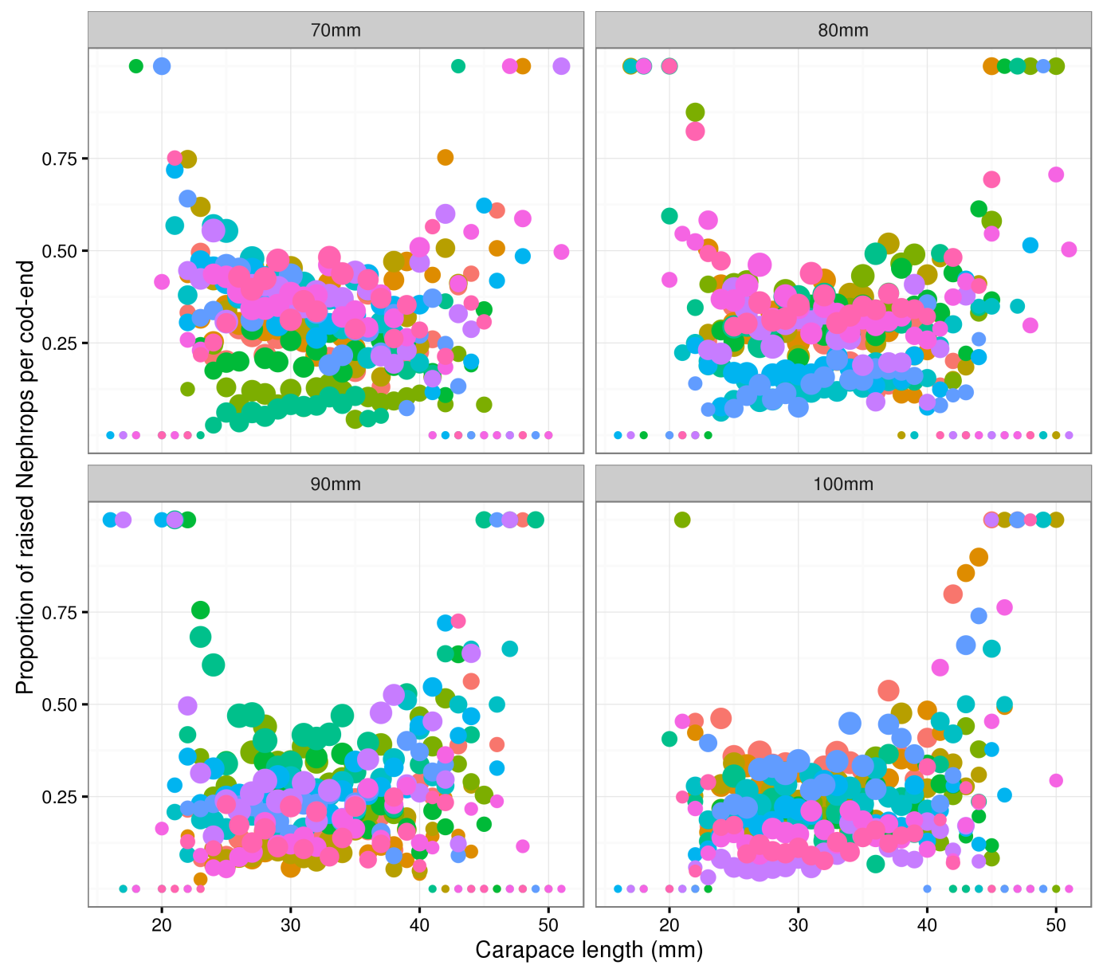

Figure 2. Multi-rig catch-comparison. Proportion of Nephrops retained per length-class by diamond mesh size. Hauls are coloured to demonstrate the haul effects. The diameter of the points is proportional to the log base 10 of the raised counts to illustrate where the distribution of the counts.

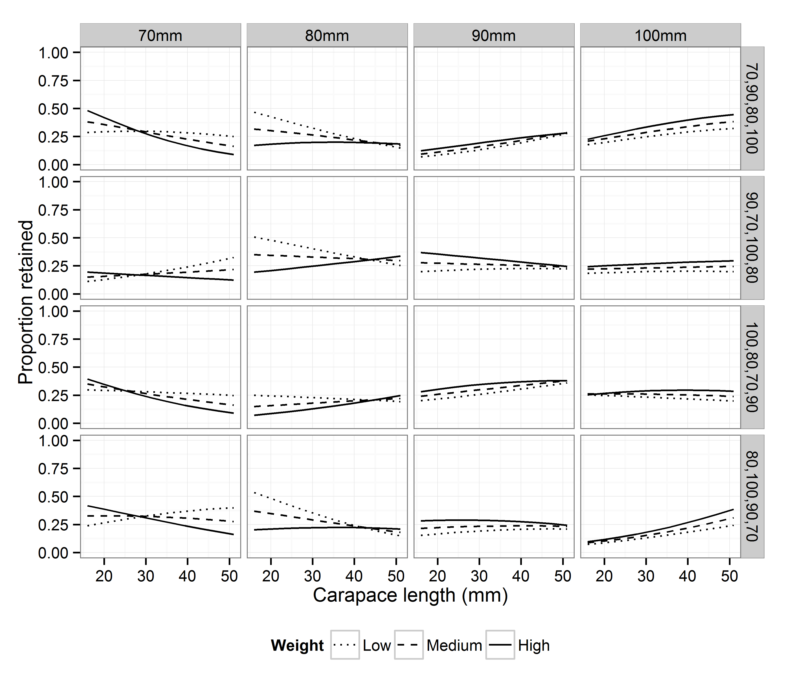

Figure 3. Multi-rig catch comparison. Predicted proportions based on fixed effects by cod-end mesh size (column) and net configurations implemented in the trial (e.g., 70,90,80,100 cod-ends were in positions: port outside, port inside, starboard inside, and starboard outside, respectively).

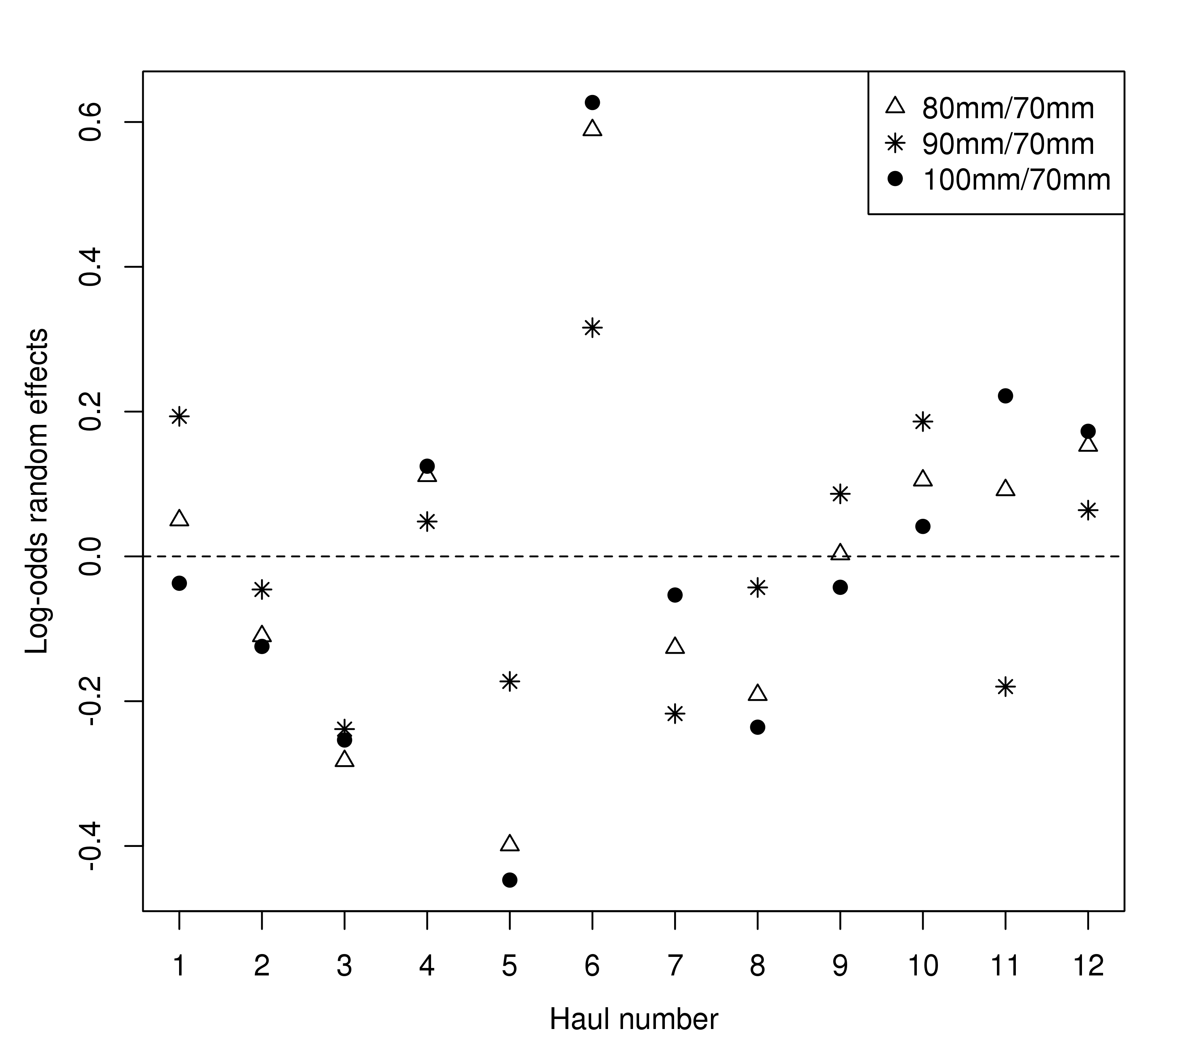

Figure 4. Multi-rig catch comparison. Estimated trivariate random effects (log-odds ratios to the baseline 70mm case: in Equation 6) by haul.

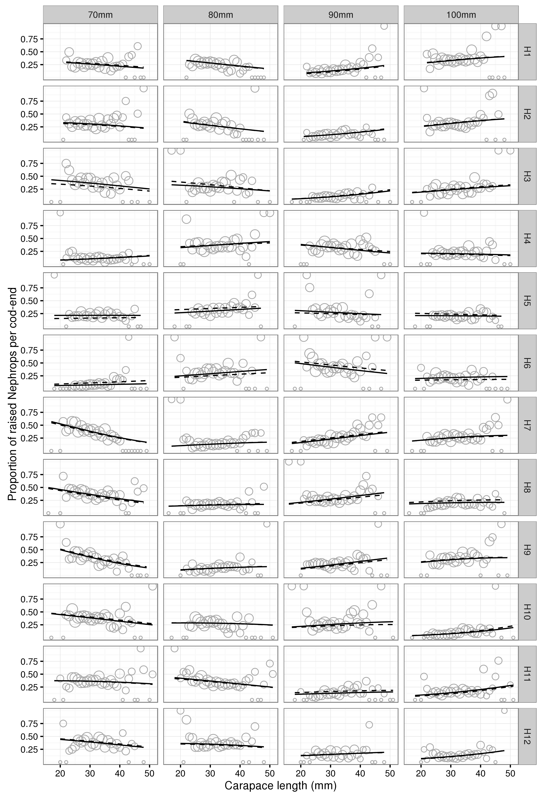

Figure 5. Multi-rig catch comparison. Fitted multinomial mixed effects proportions by haul. Solid and dashed lines represent the predictions from the best fitting model with and without random effects

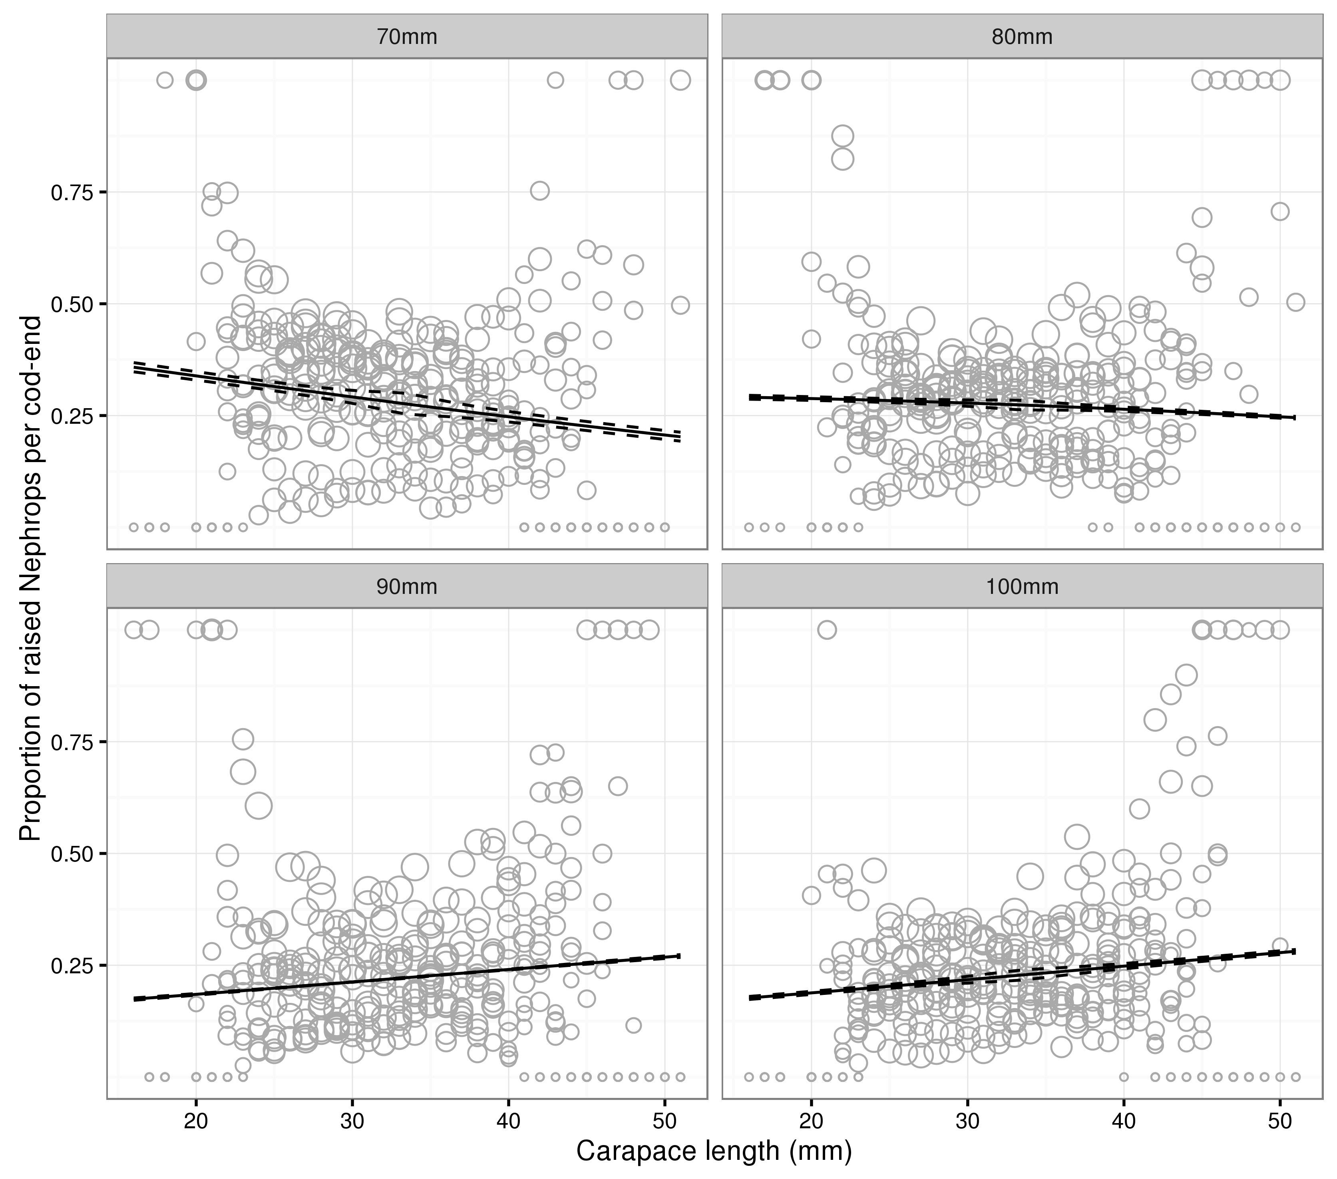

Figure 6. Multi-rig catch comparison. Overall predicted proportions at length. Solid and dashed lines represent the mean and 95% confidence intervals on the mean (see text for discussion on confidence intervals in this setting).

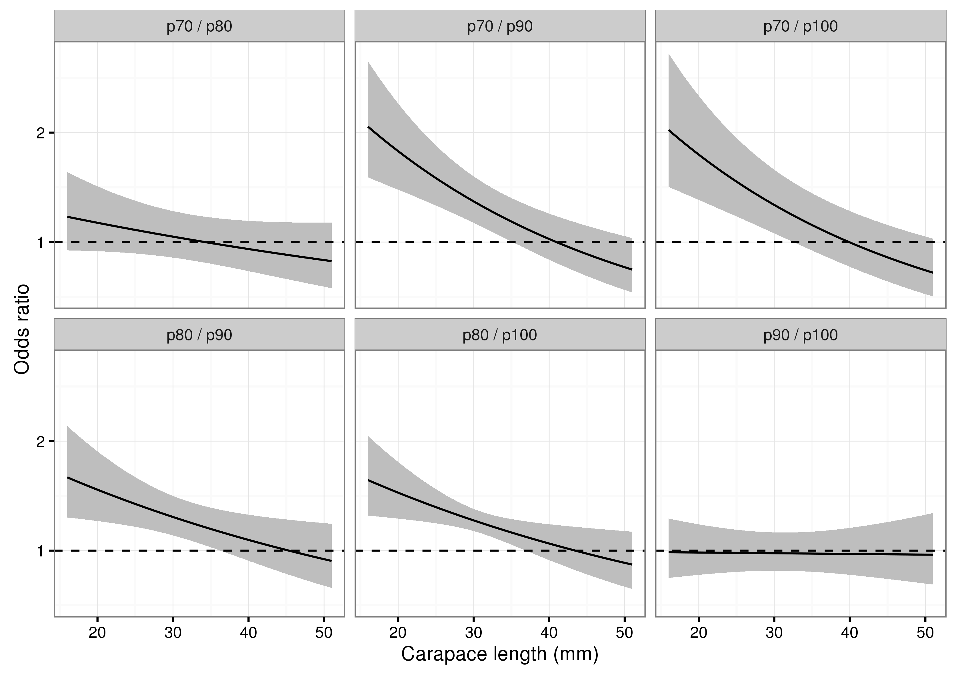

Figure 7. Multi-rig catch comparison. Pairwise odds ratios obtained by setting cod-end mean weights and equal position effects. 95% confidence intervals are pointwise Bonferroni corrected for the six comparisons made.